

Faculty of Engineering and Applied Science

SOFE 3490U: Software Project Management

Lab #1

January 17, 2023

Javier Chung (100785653)

1. Initialized github from local file

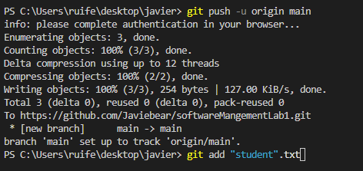

1. Create and edit Student.txt and added it

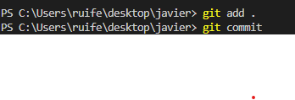

1. Git commit to main branch

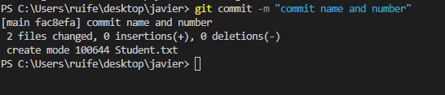

1. Created ignoreExample.txt edited contents, added file and committed and pushed

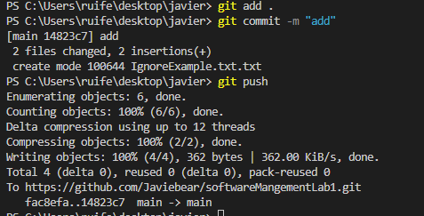

1. Git Status



1. Create .gitignore file

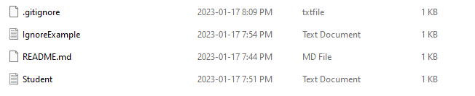

1. Create and edit .gitignore file

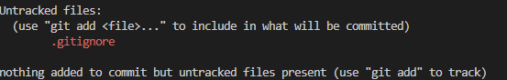

1. Open new branch and commit a edited branch text file

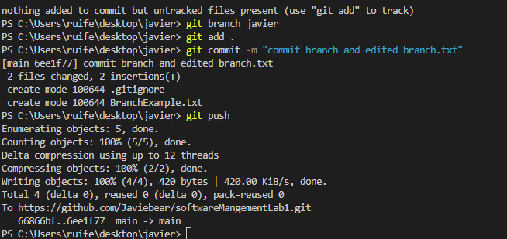

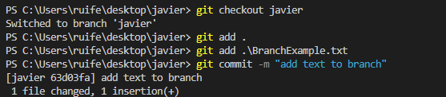

1. Screen shot of notepad command

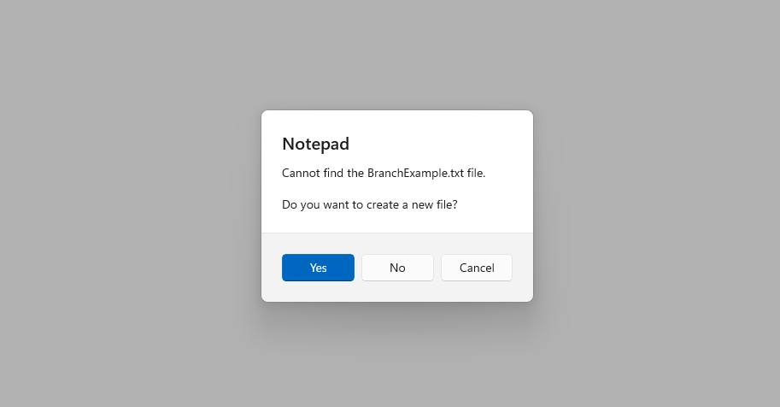

1. Create and remove RemoveExample.txt

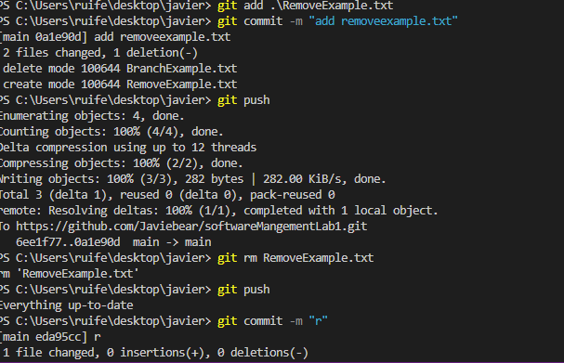

1. Screen shot of git status



1. Screen shot of git clean and status

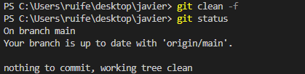

1. Add the google docs file onto the repository

